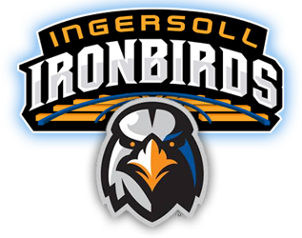
2018 Fastpitch Pitching Clinic Registration Form
6 sessions for $40 – St.Jude’s elementary school in Ingersoll
Tuesday Nov.13/2018 – Tuesday Dec.18/2018

Players Name: |  |  | Date of Birth:
Address: |  |  | Town/City:
 |  |  | Postal Code:
Parent/ Guardian:
Phone (1st Preference): |  | Phone (2nd Preference):
Email:
Parent/ Guardian:
Phone (1st Preference): |  | Phone (2nd Preference):
Email:
Beginners or pitchers with < 2 years experience  Please Circle |  | 7pm – 8pm
Pitchers with >2 years experience  Please Circle |  | 8pm – 9pm

Registration Fees are due on or before Tuesday November 13th, 2017. If paying by cheque please make payable to Ingersoll Minor Baseball Association. Any questions please contact Leslie Wright at jl_wright@rogers.com .

Indoor Fastpitch Pitching Clinic Waiver Form 2018/2019

I acknowledge my or my child’s voluntary participation in the Ingersoll Minor Baseball pitching clinic sessions; I understand that while participating in this clinic, there is a risk of injury. I understand that such an injury can range from minor to major injury.
I hereby waive any and all claims, causes of action, right to entitlement, suites, or damages against the Ingersoll Minor Baseball Association, including any and all employees, agents, or representatives, as a result of, or in conjunction with my participation during this clinic. I also waive any and all claims to any other services uniforms, equipment, medical or training services and the like.
I verify that I have no physical disabilities, impairments, or chemical dependencies that inhibit my participation in this clinic. I do not know of any medical reason why I should not participate in a pitching clinic for my sport. I hereby accept and assume the risk of injury and understand the possible consequence of such injury up to and including death.
I, the undersigned, have read this form carefully and understand all its items.
Signature of Participant/ Athlete: |  | Date
Signature of Parent/ Guardian: |  | Date

